# Baseline ARIMA individual

Individual ARIMA prediction -- Mean RMSE: 191.46919642712257

Individual ARIMA prediction -- Mean MAPE: 0.24285821353214496

# LightGBM

## 1 By individual

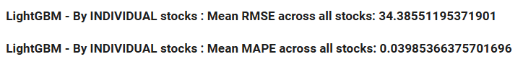

## 2 By global

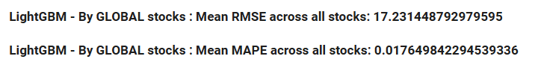

## 3 By cluster

* **Stock_5_cluster_df (best performance among all clustering methods, but still worse than global)**

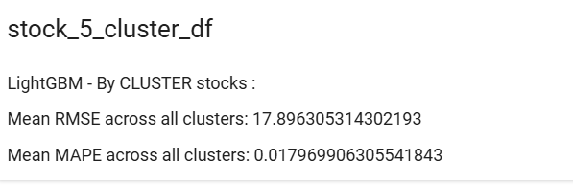

* stock_8_cluster_df

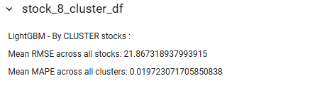

* fft_direct_kmeans_8

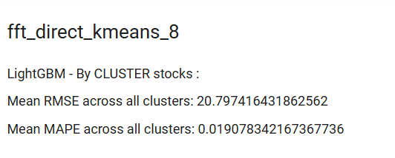

* fft_direct_kmeans_5

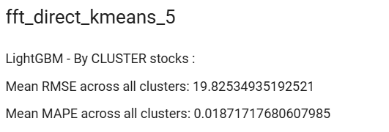

* fft_set_agglomerative_8_cluster

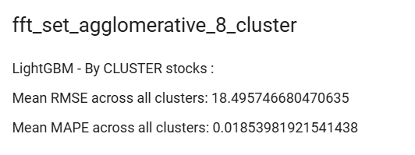

* fft_set_agglomerative_5_cluster

